

prepPad

A job-matching & tracking platform designed for students.

TEAM 5:
Cristian Mejia
Olatunde Mojisola
Davey Renoid
Benita Chinemerem

Project Status Update

Spring 2025
Software Development
ITWS-6700
Prof. Richard Plotka

TABLE OF CONTENTS

Summary Intro 3
Technology and tradeoff (stack and decisions) 3
Frontend 3
Backend 4
Database 5
Infrastructure 6
Project Management 10
Current Progress (Mockups, wireframes, early results, prototypes, problems) 11
User Flow 11
Wireframe 12
Usability Heuristics 12
For the design of the prepPad, we applied certain usability heuristics while designing such as 12
Early Results 14
Project Structure and Management 14
Frontend Development 14
UI/UX 14
Backend Development 14
Database Implementation 15
DevOps 15
Problems 15
Challenges Encountered with DevOps 15
Blurred Background 16
Web Parsing 16
Plans for Completion 17

Summary Intro
prepPad is a job‐matching and tracking platform designed for students who struggle with ATS rejections and inefficient resume tailoring. It focuses on helping users quickly compare their resumes to job postings to identify critical skill gaps. The system automates resume parsing, job posting analysis, and personalized learning plan generation—all at low or no cost. The project is focused on streamlining the application process, providing actionable insights, and bridging the gap between a student’s current skills and job requirements. ​

Technology and tradeoff (stack and decisions)

Frontend
- NextJS (React)
  - React’s extensive component ecosystem allows us to leverage thousands of pre-built components to quickly assemble interfaces without building everything from scratch.
  - Its server side rendering capabilities significantly improves initial page load time, which is crucial for user retention. This provides a more responsive UI experience right from the start for students with varying internet speeds.
  - Its file based routing removes the need to configure complex route structures. Adding new pages is as simple as creating a file in the pages directory. The development server automatically refreshes the browser when changes are made, creating a tight feedback loop that speeds up the iteration process.
  - NextJS allows you to build API endpoints directly in your project which eliminates the need to set up a separate backend service during prototyping. It is compatible with various databases which allows us to choose the appropriate data layer for our needs.
  - Its incremental static regeneration allows us to static content without rebuilding the entire site which is perfect for updating job listings or resource pages periodically without performance issues.

- TailwindCSS
  - There’s a low learning threshold which enables students without deep CSS expertise to quickly become productive. It eliminated the need to create and maintain a custom CSS architecture.
  - TailwindCSS integrates perfectly with NextJS providing optimized builds and compatible hot reloading. It also works seamlessly with Typescript, allowing us to build type-safe components with consistent styling.
  - It has built in darkmode support which is valuable for students who may be job searching late at night.
  - Developers can stay within component files instead of jumping between HTML, CSS and JS files.
  - TailwindCSS produces remarkably small CSS bundles by purging unused styles, resulting in faster loading times and better performance.
- Authentication Integration
  - Social login via Auth0 was removed and a custom-JWT authentication was chosen instead. NextAuth.js works directly within our NextJS application, eliminating the need for a separate authentication service and reducing hosting costs.
  - NextAuth.js requires less boilerplate code and configuration than Auth0, which typically needs separate SDKs and configuration files.
  - For communication with our Django backend, NextAuth.js provides straightforward methods to secure API requests with authentication tokens.
  - Seeded test users were made to save time and streamline initial development.

Backend
- Django (Python)
  - Rapid prototyping and ease of use streamline development and testing.
  - Built-in server-side rendering enables quick frontend prototyping.
  - Models store structured data (resumes, job postings, file uploads).
  - Forms simplify file/job posting uploads and validation.
- LXML
  - Replaced Beautiful Soup for faster, more consistent HTML parsing of job postings.
  - Efficiently removes tags and extracts raw text (critical for unstructured job descriptions).
  - Less forgiving than Beautiful Soup for malformed HTML.
  - Requires precise XPath/CSS selectors due to varying job-posting layouts.
- Deepseek V3
  - Chat interface simplifies resume/job posting parsing via natural language prompts.
  - Cleans and sections text (e.g., extracts skills, qualifications) with minimal code.
  - API dependency (risk of rate limits or downtime).
  - Less control over model behavior compared to fine-tuned local models.
- Hugging Face Transformers (bert-base-NER)
  - Pre-trained NER models identify entities (skills, locations) without training.
  - Integrates seamlessly with Python workflows.
  - Generic training data may miss domain-specific terms (e.g., niche job titles).
  - GPU required for optimal performance (CPU inference is slow).

Database
For the database, we are still using PostgreSQL for its ACID compliance, reliability, and support for complex data relationships between users, resumes, job postings, and matching data. For the frontend, we used Supabase (a dedicated postgresql platform) where the user name table is present with a seeded user (present with a unique id).
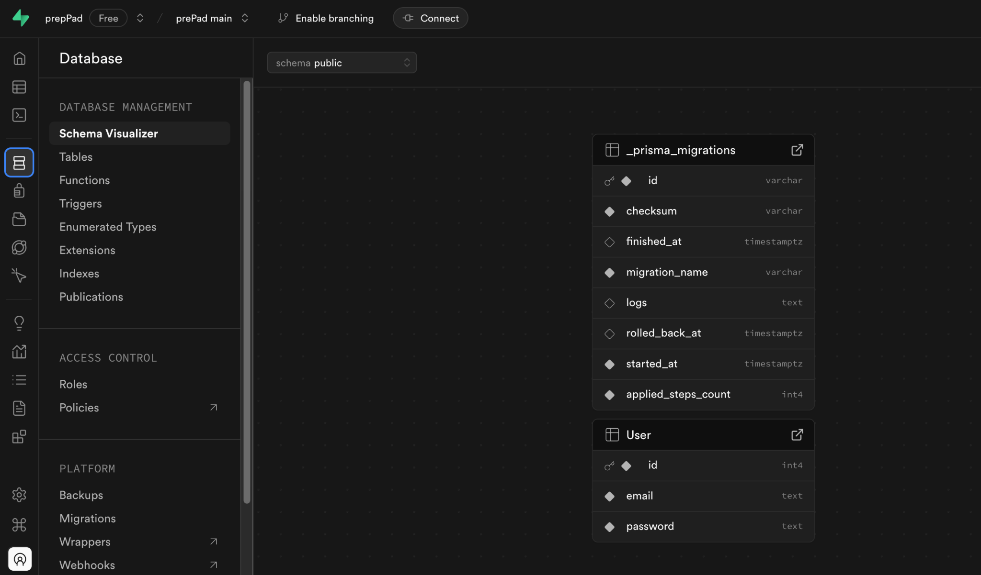
Current prepPad user schema (Supabase)

For the backend, the postgresql database for the resume is on a docker container which assigns a unique id to the currently uploaded resumes. In the coming days, the end points will be established (user & resumes) and the tables (user and resumes) will be linked by assigning a user id to a resume.

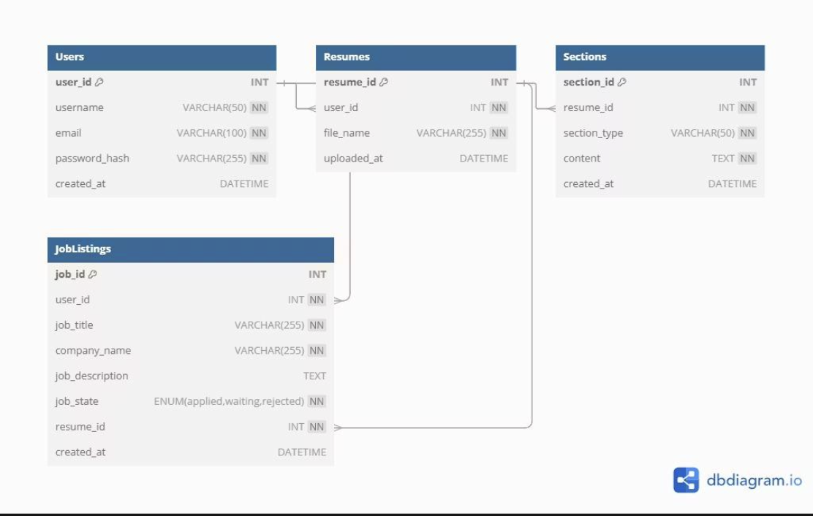
Final Database Design (Schema)

Infrastructure
PrepPad CI/CD Implementation

Here we are working on establishing a DevOps pipeline to handle continuous integration and deployment.
Repository Structure Decision
After reviewing the project requirements, we decided on a monorepo approach instead of separate repositories. This approach simplifies collaboration, dependency management, CI/CD workflows, and debugging, making development more efficient for our four-person team.
Easier Collaboration
A unified repository ensures everyone knows where to find the code, reducing the need to switch between multiple repositories. Changes affecting both frontend and backend, like adding a new API endpoint and updating the UI, can be committed together for better tracking and review.

Simpler Dependency Management
Shared dependencies, such as configuration files and environment variables, can be managed in one place, ensuring compatibility as both frontend and backend are developed and tested together.
Unified CI/CD Pipeline
A single GitHub Actions workflow can build, test, and deploy both frontend and backend, ensuring synchronization and immediate feedback if a change introduces an issue.
Efficient Project Management
Managing one repository is simpler, eliminating the need to coordinate changes across multiple repositories or set up separate workflows.
Easier Debugging and Testing
With both frontend and backend in one place, end-to-end tests can cover the entire application, catching bugs early and simplifying debugging.
The initial repository structure was disorganized with backend code in a "module-tests" folder and frontend code scattered across various locations. We decided upon an organized structure with clear separation:
Initial Structure:
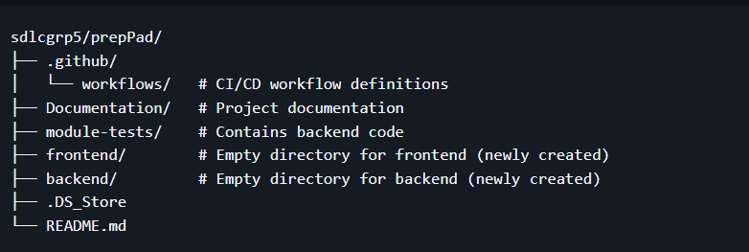

Organized Structure:
The proposed structure creates a cleaner, more standardized repository organization.
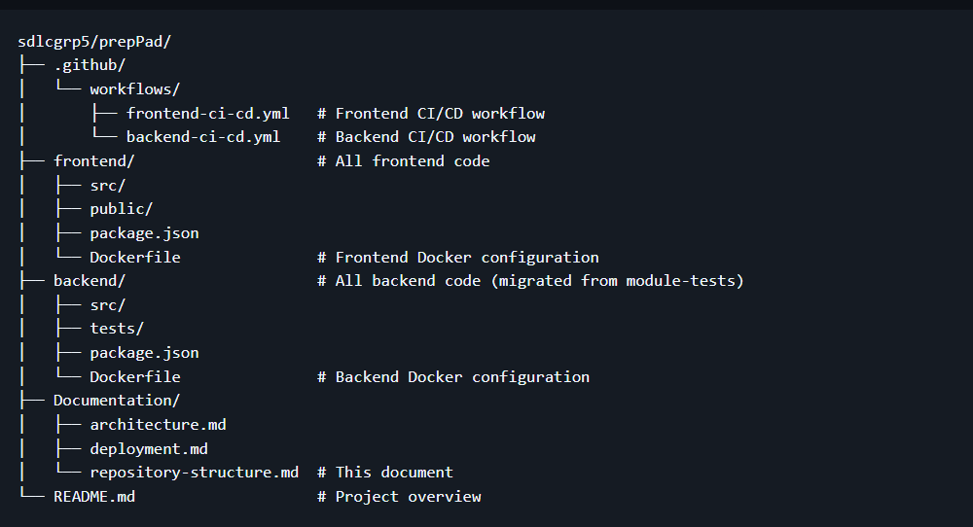

Proposed Deployment Strategy
The initial deployment strategy included GitHub Actions for CI/CD automation, Docker containers to package both applications, an Azure VM for hosting, and Nginx as a reverse proxy. This approach ensures consistent environments across development and production through containerization. It also makes the deployment process reproducible through Infrastructure as Code principles while reducing manual errors through automated testing and deployment.

Implementation Process
We began implementing the CI/CD pipeline by first setting up the environment on the Azure VM. This included installing Nginx for web serving, Node.js for the frontend, and Git for version control. Next, we created Docker configurations for both components with a frontend Dockerfile using Node.js for building and Nginx for serving, and a backend Dockerfile using the Python image provided by the backend team.
For the GitHub Actions workflow, we designed a process to build Docker images for both components, push these images to GitHub Container Registry, and deploy the applications to the VM.
We are currently fixing Docker build context issues by simplifying the workflow and adjusting paths for the nested directory structure. Once resolved, the workflow will automatically build and push container images to GHCR whenever code is updated. These images can then be manually deployed to any Docker-supported environment.
This approach ensures we have containerized applications ready for deployment while working within our resource and permission constraints.
Lessons Learned
This implementation has highlighted several important DevOps principles. The organization of code significantly impacts CI/CD processes, making repository structure a critical consideration. Beginning with a minimal working pipeline before adding complexity helps isolate issues when problems arise. Working within restricted environments requires adaptable approaches, as demonstrated by the limitations of the student Azure account. Finally, clear documentation ensures the sustainability of the deployment process.

Project Management
Methodology: Agile Methodology (Kanban)
We are currently making use of Github projects for coordinating our product backlog, based on our weekly standup, we prioritize development for different tasks required for core functionality. For example, we paused working on the job posting module when the parsing was not working fine with job posting links of popular websites (LinkedIn & Handshake) to focus more on the backend development.
A common blocker we experienced was ‘knowledge gap’ which we addressed by reassigning tasks, and creating time for learning for other members.
With the Kanban board, we are able to identify our limits as a team when it comes to tasks, and reprioritize the work.
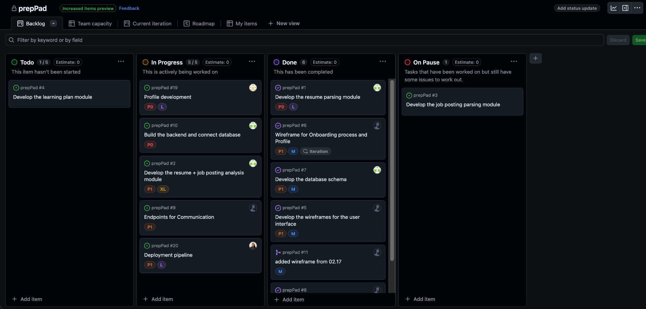

In terms of adherence (80%), the team lacked a bit once again due to the knowledge gap which prolonged certain tasks, however we overcame this by ensuring flexibility within the team.
In summary, we had to sacrifice some structure to accomplish certain tasks; this included building certain aspects of the project ahead of schedule, changing priority for certain tasks, and other members taking up other tasks.

Current Progress (Mockups, wireframes, early results, prototypes, problems)

User Flow

The user flow begins with the registration, where users choose their Sign Up Method - either Email or Social. Email users proceed through Email Sign Up, while those preferring social authentication navigate through Social Login [Social Login is 100% certain at this point]. Both paths lead at the Resume Upload or Manual Input decision point.
If the user selects Upload, they move to the upload resume step, followed by resume parsing, which automatically extracts their information. Alternatively, choosing the manual input directs users to the interface where they enter their details themselves. Both paths then feed leads to the profile being created, completing the initial onboarding process. From the profile
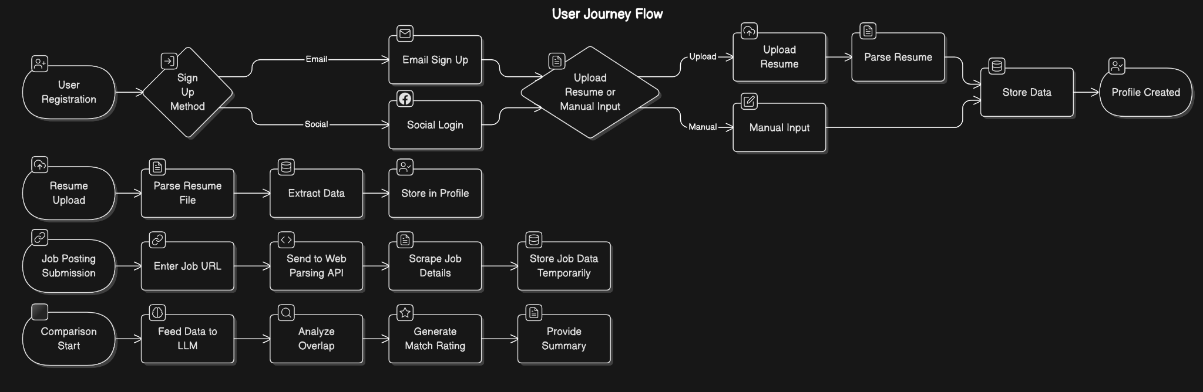
For job-resume comparison, the job posting submission process begins with entering the job posting URL, which then sends to Web Parsing API, which facilitates scraping of job details before temporarily storing this job data.
Finally, the comparison feature begins with the process, feeding collected data to an LLM (for analysis), then analyzes the overlap to generate match rating, culminating in providing a summary of the user match with specific job opportunities.
This flow show a seamless experience from registration through job matching, with alternative paths accommodating different user preferences and scenarios

Wireframe
For the structure of the platform, we ensured the landing page was minimal and short due to the nature of the target audience (fast paced and tech savvy). We created a landing page with a centralized straight forward header, a sub header, a form and call to action.

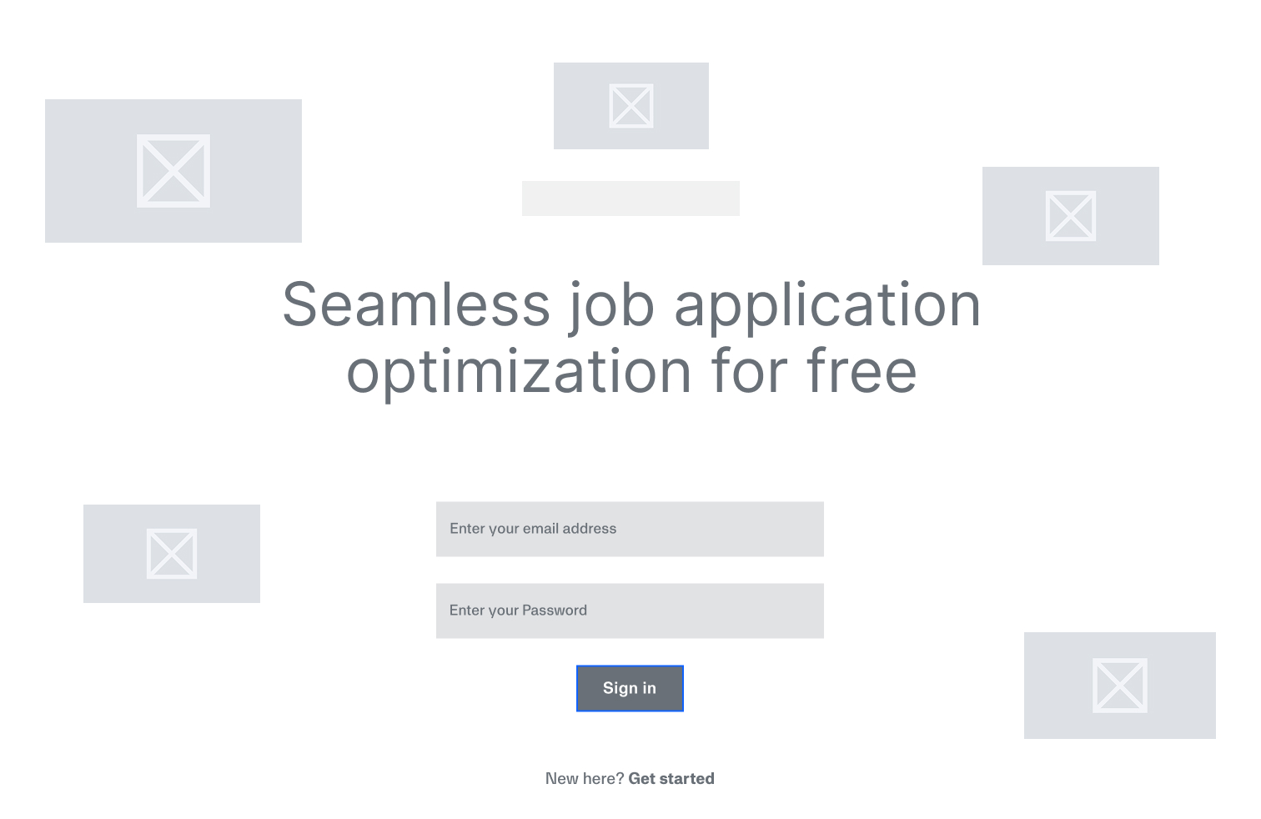

Usability Heuristics
For the design of prepPad, we applied certain usability heuristics while designing such as:
- Aesthetic and minimalism,
- Recovery from errors, and
- Consistency and Standards.

Accessibility
We also made sure we anchored the project on accessibility throughout the design phase to drive inclusion for different users within our target audience, including those with eye defects. Based on the scheme chosen we were able to achieve the standard AAA for all criteria.
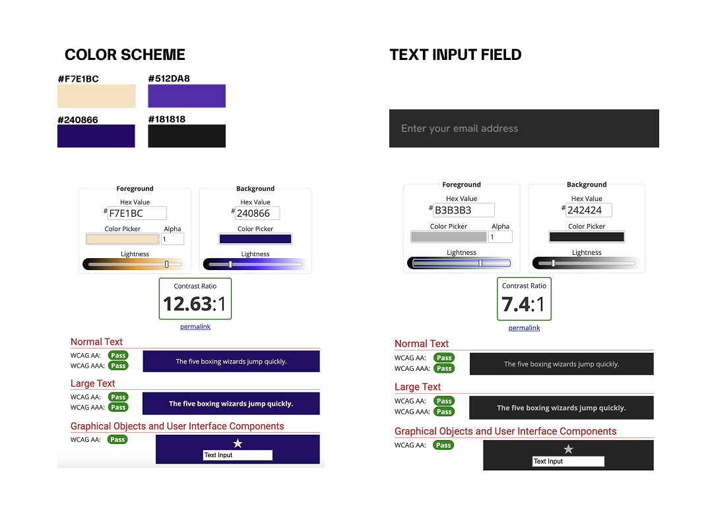

Dark mode
For the UI, we made a user-first decision by placing the target audience (young college students and early professional) in consideration by using dark mode first . According to a survey by Adobe, 73% of Gen Z respondents expressed a preference for dark mode over light mode {source}. Couple with the accessibility check, we had validation for pursuing the darkmode user interface.
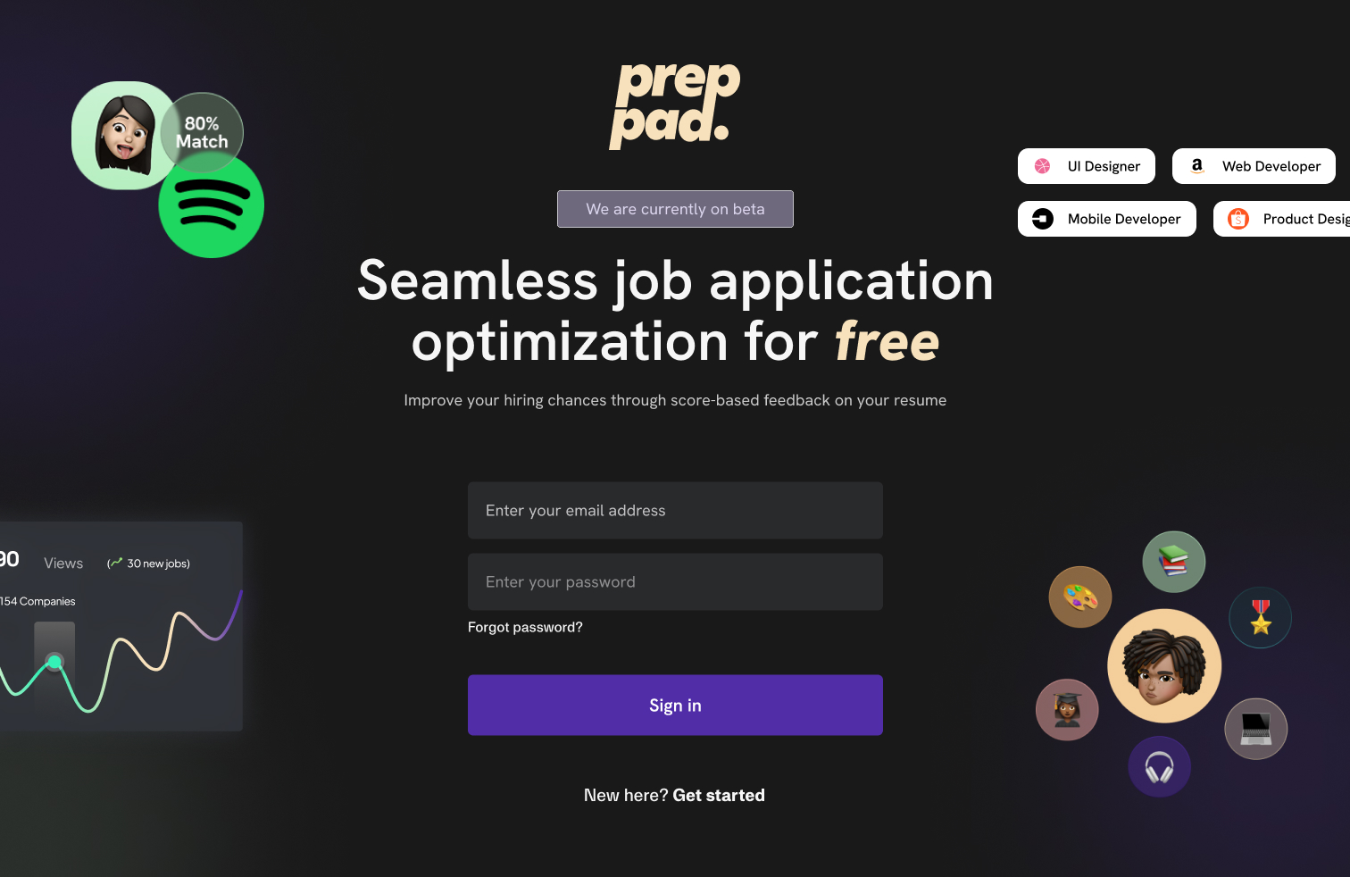

Other reasons for taking the dark mode route:
  - Dark mode UIs tends use up less energy because of the
  - Offers less strain on the eyes especially in our case where we use bigger buttons and input fields.
  - Offers us a more visually appealing interface.

Early Results

Project Structure and Management
- We’ve set up a project management tracking system that helps us monitor our progress across all components of prepPad. This is done through GitHub projects using a kanban board for coordinating our backlog tasks based on our weekly standup.
- We’ve established communication channels through discord and google doc which has enabled seamless collaboration amongst us.

Frontend Development
- Using NextJS and Tailwinds CSS, we have created a responsive UI for the following key pages:
  - Sign up
  - Log in
  - Resume upload interface
  - Manual input for profile creation

UI/UX
- Created low fidelity wireframes
- Created high fidelity mockup for entire screens
- Created a user persona to represent our student users.
- Created an end-to-end prototype of the entire user flow to validate the user journey

Backend Development
- Developed the resume analysis module. The resume parser extracts key information from a resume such as the user's name, education, experience and skills.
- Developed the job posting analysis module. The job posting parser extracts information from the job link. This information includes the title for the job, its description, and the required skills.
- Created a backend application for handling server-side logic.

Database Implementation
- Established a PostgreSQL database via Supabase for reliable and scalable data.
- We’ve modeled our database using Prisma ORM to simplify database operations.
- Created a database structure in which only the user information is saved. Once other tables are made, the resume information will be saved and connected to the user data using a unique user id.

DevOps
- Organized the repository structure with a clean separation between the frontend and backend codebases.
- Created a VM on Azure.
- CI/CD pipelines are set up for both the frontend and backend components
- Configured the docker files for the frontend and backend

Problems

Challenges Encountered with DevOps
During implementation, we faced several significant challenges. The Azure student account had limited permissions, preventing the use of some Azure-specific deployment features. Access to the VM itself was restricted, which complicated the deployment of containers since direct SSH access was limited.
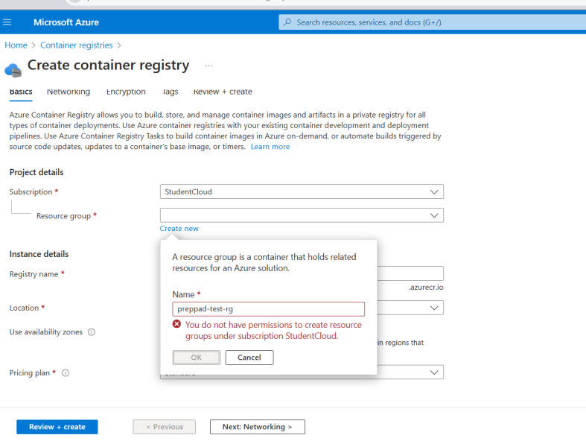

Current Status
Due to permission restrictions with Azure and SSH issues with the VM, we shifted our approach to focus on containerization without direct VM deployment. Instead of using Azure Container Registry, we chose GitHub Container Registry (GHCR) because it integrates seamlessly with GitHub and doesn’t require extra cloud permissions. This allowed us to move forward with CI/CD despite the limitations of our educational Azure environment.
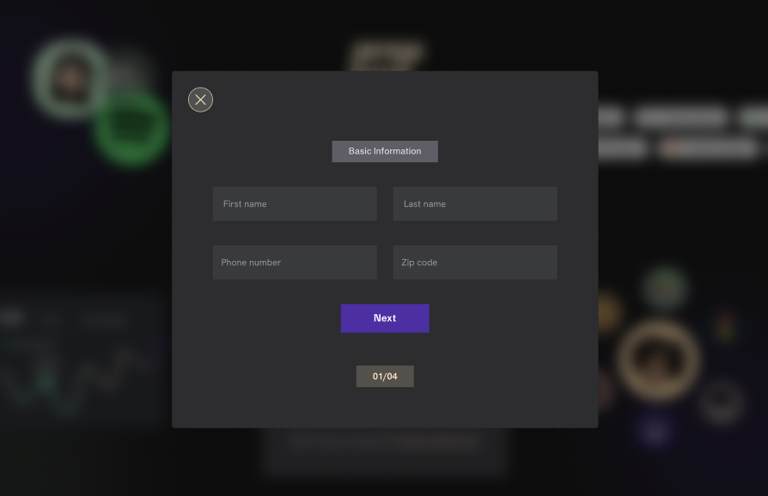
Blurred Background
We’ve experienced issues with implementing a blurred background as a frontend interactivity feature. We are currently trying to use TailwindCSS to achieve this. This has been put on hold for the moment to focus on more. We are currently prioritizing functionality over visual polish in the short term. We plan to enhance the UI in later iterations.

Web Parsing
We’ve experienced issues with parsing web pages using standard web-scraping libraries such as Beautiful Soup (BS4). Every company uses a different structure for their site and BS4 doesn’t have any capability for navigating these caveats. Instead, we switched to LXML as it is more performant but has less features than BS4. We used LXML to remove as much HTML tags and Javascript from the HTML data and then send that data to our LLM of choice, Deepseek V3. Further development of the LXML to clean the data more as there are still remnants that it doesn’t remove for some reason.

Plans for Completion

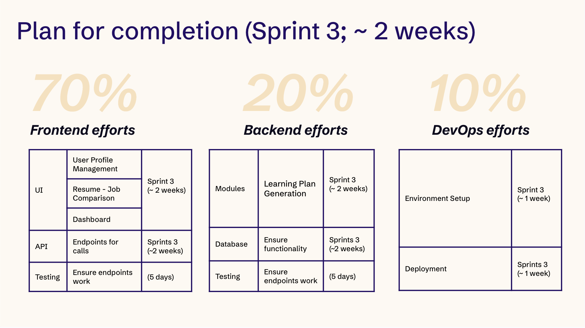

- Create endpoints for frontend-backend communication. This will allow us to test the entire flow from user signup to resume parsing to job posting comparison.
- Address web scraping challenges by focusing on job sites with public API’s or focusing on publicly accessible job sites.
- Complete the core user journey (signup → profile → resume upload → dashboard → job matching).
- Connect database tables (user → resume → profile).
- Develop and integrate the resume-job comparison feature using a machine learning model.
- Implement end-to-end testing, gather user feedback, and perform iterative refinements.
- Confirm deployment.
- Update project documentation, finalize wireframes and high-fidelity mock-ups to reflect any UI changes, and prepare for the final project submission.

